Improvement Detail Panel Instructions

HIGH LEVEL OVERVIEW

Improvement Details are all of the components that make up the Improvement. For example, in the case of a single family residence, typical improvement details might include a main floor, second floor, an attached garage, and an unfinished basement. In PACS 9.0, each detail type is user-defined, and can be valued with a schedule.

The purpose of this document is to provide specific data entry instructions on how to:
- Create a new Improvement Detail
- Edit Improvement Detail panel fields
- Add, Edit or Delete an Adjustment to an Improvement Detail – Page 26
- Add New Construction Value to an Improvement Detail
- Delete an Improvement Detail

NOTE:
ALL OF THESE INSTRUCTIONS ARE WRITTEN BASED ON THE USER WORKING IN THE CURRENT (UNCERTIFIED) YEAR LAYER
Section xx – Creating a New Improvement Detail

There are two ways to create a new Improvement Detail. First you can open the Improvement and create the new Improvement Detail from the Improvement Level. Alternatively you can take a shortcut and create a new detail directly from the Details grid on the Improvement Summary Panel. This set of instruction will demonstrate creating the new detail from the Improvement Level (i.e. the user opens an Improvement, then creates the detail).

If you do not need to create a new Improvement Detail, then skip to the section titled “Edit Improvement Detail Data”, otherwise continue as instructed below:

- Open the PID where the new Improvement Detail is to be created
- Select the Improvement Panel and the following panel will open: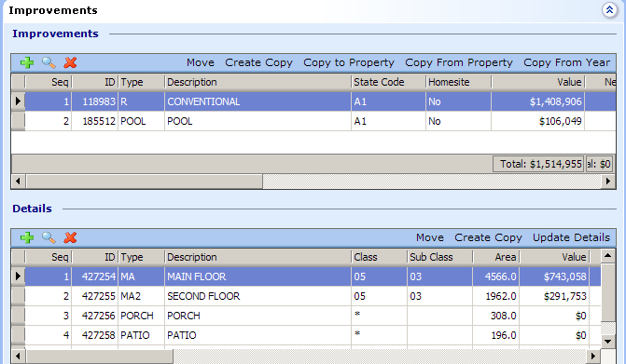
- If you are adding an “Additional Detail” to an existing Improvement, the Improvement will be shown in the top grid (Improvements) together with its preexisting details shown in the bottom grid (Details).
  - Visually identify the correct Improvement in the grid above – this is the improvement where you want to add the new Improvement Detail
  - Select the desired Improvement
  - Select the Detail button to open the Improvement. An Improvement Dialog screen will open. The part of the screen you want to look for is the Improvement Details Summary Grid that looks like this:
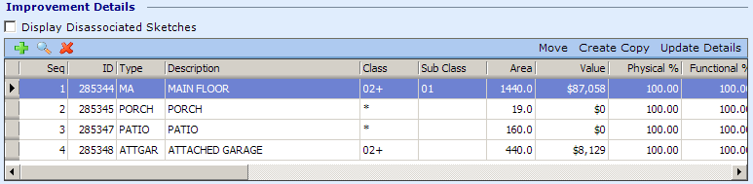
  - Select the green Plus sign to create a new Improvement Detail.
  - A new “blank” Improvement Detail dialog now opens as indicated at the top of the banner: as shown below in Image XXX
  - Populate the fields according to the instructions in Section XX: titled “Edit Improvement Detail Data”
- If you are adding an improvement Detail as a result of a brand new Improvement, you will need to first create the New Improvement using the instructions provided in Section XX – Creating A New Improvement, then follow the steps found above in 3a through 3f.
Remember to check the “New Value Checkbox, if it is new construction
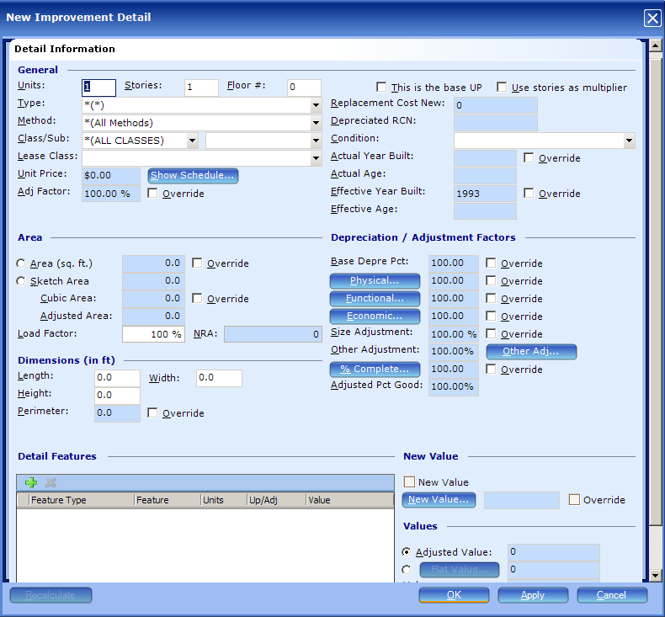
Image XXX – New Improvement Detail
Image XXX is generated from step 3) d. above

Section XX: Edit Improvement Detail Data

- Open the PID for the parcel where edits are to occur
- Select the Improvement Panel, the following screen opens: 

- If only one Improvement exists on the account, select that Improvement and select the Detail button , else
- Observe the available Improvements in the grid. Locate the one that will have edits made to its details
- Select and open the appropriate Improvement. An Improvement Dialog screen will open. The part of the screen you want to look for is the Improvement Details Summary Grid that looks like this:
Alternate process, see Step 6
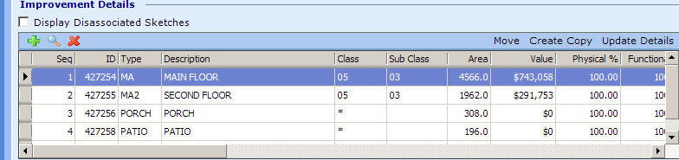
- Select the Improvement Detail from the Improvement Detail Grid and continue with Step 7 or to update multiple details at one time select the Update Details button and follow the instructions provided on Page 24 in the Improvement Panel Instruction User Manual.
- Select the Details button to open the Improvement Details panel shown below:
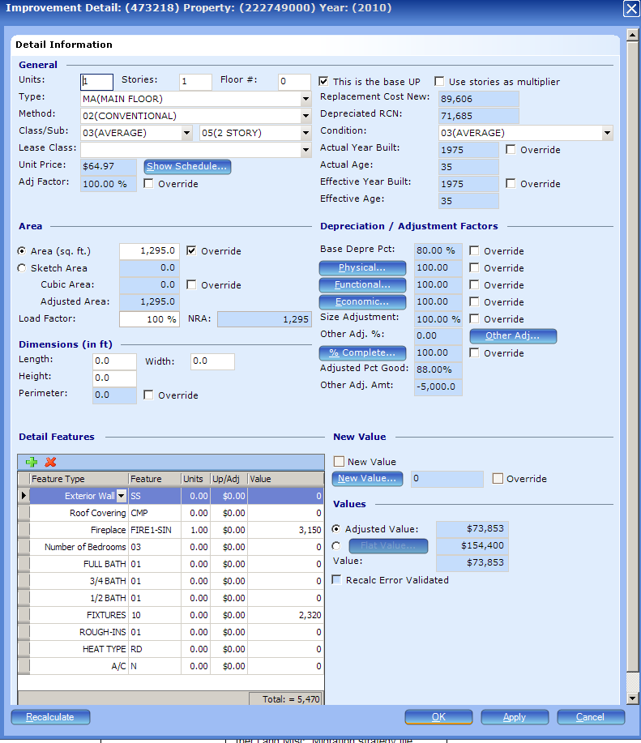
Improvement Detail Panel

From Step 7 above, the Improvement Detail Panel for the selected Improvement Detail is now displayed.

- Verify and/or edit the data displayed in fields on the Improvement Detail dialog as follows:

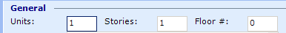

Units
(Tab Stop 1) To add to or edit the field, click inside the data entry box and input the correct number of units. Note: This field is an information only field.
Currently, Units is a multiplier against the Area (sq.ft.) field and typically will be used by Multi-family appraisers when enter unit information. See Appendix XXXX for a MF example.

Stories
(Tab Stop 2) To add to or edit the Stories field, tab to or click inside the data entry box and input the correct number of stories.

User Tip: the user should be aware that the Stories field acts as an Area (sq.ft.) field multiplier when the checkbox is active (checked). For commercial properties, this checkbox should be checked. For example, if the subject property is a two story office building with 5,000 sq.ft. of floor area on each floor, the user can input a ‘2’ in the Stories field, activate the checkbox, and input 5,000 sq.ft. into the Area (sq.ft.) field. PACS will multiply the 5,000 sq.ft. by ‘2’ to calculate an Adjusted Area = 10,000 sq.ft.
For Multi-family properties…. (fill in notes here later after Roni decides best business practice)
For Residential Condominium properties - Use this field to enter the number of stories for the condominium complex. Note: thecheckbox should not be checked.

Floor #
(Tab Stop 3) To add to or edit the Floor # field, tab to or click inside the data entry box and input the correct floor number. This field is an information only field.

Commercial User Tip: Currently, the Commercial Division is not using this field, since we are using the average floor area concept migrated from CATS. However, if the user creates improvement details where each detail represents a specific floor of the improvement, then the user should populate this field with the correct floor number for the detail.
Residential User Tip: For Residential Condominium properties: Use this field to enter the floor number on which the specific condominium unit is located. This would be the Floor # for the condo complex, e.g., third floor of a 10-story Condo Complex, not the floor number of the condo unit. For all other Residential properties, accept the field at the default value of zero (0).

Type, Method, Class and Sub-Class (TMCS)

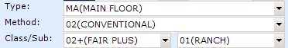

User Tip: Type, Method, Class and Sub-Class are used to lookup the detail’s corresponding cost schedule. The user should be especially careful in selecting the correct entry for these fields in order to produce an accurate value for the improvement and to maintain equity with other similar improvements when valuing properties on the cost approach.

Type
Type (Tab stop 4) is used to describe the Improvement Detail’s Type.
To make a change to the Type field, click on the drop down arrow, use the scroll bar to navigate to the correct code, and then select the code from the menu.

User Tip: A navigation shortcut provided in PACS allows you to click into the drop down field, then type the first letter of the choice for which you are looking. This shortcut is helpful when the list is very long and you know about where you need to be or the exact code for which you are looking.

Commercial User Tip: When entering residential improvements, you must follow the residential data entry guidelines.

Administrator User Tip: In the improvement detail type code file, there are options that allow the user to designate whether or not the improvement detail is a Main Area type (all main area types are added up on the improvement to determine the total main area of the improvement). SRD 2003, pg 14, Item I. This will also determine the total square footage for schedule lookup/pricing.

For Residential property use the following key to make the appropriate entry in the Type field
Approved Detail TYPE codes for Residential data entry:
When the Detail type is: |  | Use This Detail type code:
For use with Conventional , Condo, Zero lot line, and Duplex Improvements
Attached Garage | ATTGAR
Basement Garage | BSMTGAR
Built-in Garage | BUILTINGAR
Carport | CARPORT
Day Finished Basement | DAYFNBSMT
Day Unfinished Basement | DAYUNFBSMT
Deck | DECK
Finished Basement | FNBSMT*  *Note: do not confuse this with the Improvement Detail type of ‘BSMT’ or ‘FINBSMT’, which are currently on some Commerical properties.
Main Floor | MA
Patio | PATIO
Patio Cover | PATCOV
Porch | PORCH
Second Floor | MA2
Unfinished Basement | UNFBSMT
Third Floor | MA3
Auxiliary Living Area (attached) | AUX
Elevator/Passenger | EP  *Note: enter a passenger elevator when you want to add value – else add as a improvement detail Feature. Currently, there are no schedules for Elevators.
For Use with Mobile Home Improvements
Mobile Home (main floor) |  | MH
MH Attached Garage |  | MHATTGAR
MH Basement Garage |  | MHBSMTGAR
MH Carport |  | MHCARPORT
MH Day Finished Basement |  | MHDFBSMT
MH Day Unfinished Basement |  | MHDUFBSMT
MH Unfinished Basement |  | MHUNFBSMT
MH Finished Basement |  | MHFNBSMT
MH Built-in Garage |  | MHBLTINGAR
Note: MH Improvement Details should be added with a Improvement Detail Method = 03(Mobile Home)
For Use With Detached Garage Improvements
Detached Garage |  | DETGAR
For Use with Pool Improvements
Pool |  | POOL
Outbuilding Improvements
Apartment |  | APARTMNT
Arena |  | ARENA
Barn |  | BARN
Carport (valued separately from main improvement) |  | CARPORT
Church |  | CHURCH
Club House |  | CLUB HOUSE
Deck (valued separately from a main improvement) |  | DECK
Firehouse |  | FIREHSE
Float |  | FLOAT
Foundation |  | FOUNDATION
Garage (valued separately from a main improvement) |  | GARAGE
Gazebo |  | GAZEBO
Grange |  | GRANGE
Green House |  | GREENHSE
Guesthouse |  | GUESTHOUSE
Gutters |  | GUTTERS
Hangar |  | HANGAR
Kennel |  | KENNEL
Lean-to |  | LEANTO
Loaf shed |  | LOAFSHED
Machine Shed |  | MACHSHED
Milk house |  | MILKHSE
Office |  | OFFICE
Piling |  | PILING
Pole barn |  | POLEBARN
Pool house |  | POOLHSE
Poultry |  | POULTRY
Recreational Room |  | REC ROOM
Restroom |  | RESTROOM
Roof Cover |  | ROOF COVER
Sauna |  | SAUNA
School |  | SCHOOL
Shed |  | SHED
Shop |  | SHOP
Silo |  | SILO
Skirting |  | SKIRTING
Sports Court |  | SPORTS CRT
Stable |  | STABLE
Storage |  | STORAGE
Substation |  | SUBSTAT
Sun Room |  | SUN ROOM
Warehouse |  | WAREHSE
Well house |  | WELLHSE

See detailed data entry instructions in Appendix XYZ below
For Commercial property, use the following key to make the appropriate entry in the Type field

Approved TYPE codes for Commercial data entry:
When the detail type is: |  | Use the following TYPE code
ASPHALT |  | ASP
SERVICE STATION BOOTH |  | B
ALL BASEMENT TYPES  Note: You will use Sub-class to distinguish the type of basement (i.e. Finished, Unfinished) |  | BSMT
CONCRETE SHIPPING DOCK |  | CONCSHIP
CAR WASH – AUTOMATIC |  | CWA
CAR WASH – DRIVE THROUGH |  | CWD
CAR WASH – SELF SERVE |  | CWS
FENCE |  | FENCE
DOCKHIGH LOADING WELL |  | LOADWELL
KITCHENS |  | Being researched – do not use yet
MAIN FLOOR  (APTS, MOST COMMERCIAL, INDUSRIAL PROPERTIES) |  | MA
MEZZANINE  Note: You will use Sub-class to distinguish the type of Mezzanine area (i.e. Finished, Unfinished) |  | MEZZ
MOBILE HOME PARK |  | MHP
STEEL LOADING DOCK |  | STEELOAD
SERVICE STATION |  | SVSTN
STORAGE TANKS |  | TANKS
LOADING DOCK - WOOD |  | WOODLOAD
SHIPPING DOCK - WOOD |  | WOODSHIP
WOOD ROOF (BANK CANOPY etc) | From old Lump Sum | WDROOF
STEEL ROOF (BANK CANOPY etc) | From old Lump Sum | STROOF

Commercial Appraiser User Tip: While conducting Reval assignments, you will find Improvement Details that were migrated from the CATS ‘Outbuilding’ screen that are set to a Method = SP (Special Property). As of 3-2-2009, these types of details are not schedule driven. You will need to make a decision to leave them on SP and update the flat value (or not) or change the T,M,C,S (Type, Method, Class, Sub-Class) and other characteristics to match an existing commercial improvement schedule. Some examples include details where the TYPE field is populated with “STORAGE”, “STABLE”, “APARTMNT”, “LEANTO” “SHOP” and “SHED”. If you decide the detail should no longer be valued on the SP method, you must verify that a schedule exists for the new T,M,C,S fields to which you want to change the detail, prior to making the change or else you will get a recalculation error. You should also discuss your intentions at the weekly Commercial Division meeting.
Note to David and Mark: can we shrink the type list above by creating a Type called SID(Special Improvement Detail) and move the current entry in the list to the Method table.
Example: instead of having Type = Kitchen; we could have Type = SID and Method = Kitchen. True? (How much clean up would this take? When?)

The link below is for David and Tami only. Please do not use it!
This table should display all occurrences of Improvement Detail Type in NH 0-9999
..\..\1.Conversion Topics\Issues - Commercial\OLTP - Improvement Detail Type Count w Description.rpt

Method
Method (Tab stop 5) is used to describe the Improvement Detail’s Method.

To make a change to the Method field, click on the drop down arrow, use the scroll bar to navigate to the correct code, then select the code from the menu.

Commercial User Tip: When entering residential improvements, you must follow the residential data entry guidelines.

For Residential property, use the following key to make the appropriate entry in the Method field

Approved METHOD CODES for Residential data entry:

If the Improvement is a: | Detail types that use this method | Use Method code: | Method Code Description
Conventional Building | ‘MA’, ‘MA2’, ‘MA3’, and ‘MA4’ | 02 | Conventional
Mobile Home | ‘MH’  New 2010/2011:  ‘MHATTGAR’, ‘MHBSMTGAR’, MHCARPORT’, ‘MHDFBSMT’, ‘MHDUFBSMT’, ‘MHUNFBSMT’, ‘MHFNBSMT’, ‘MHBLTINGAR’ | 03 | Mobile Home
Cabin | ‘MA’, ‘MA2’, ‘MA3’, and ‘MA4’ | 04 | Cabin
Houseboat/Float Home | ‘MA’, ‘MA2’, ‘MA3’, and ‘MA4’ | 04 | Cabin  Note: we are currently using ‘cabin’ cost tables to value houseboats
Duplex | ‘MA’, ‘MA2’, ‘MA3’, and ‘MA4’  New 2010/2011:  ‘ATTGAR’, ‘BSMTGAR’, ‘BUILTINGAR’, ‘CARPORT’, ‘DAYFNBSMT’, ‘DAYUNFBSMT’, ‘DETGAR’, ‘FNBSMT’, ‘UNFBSMT’ | 05 | Duplex
Inner Unit (or Common wall unit) | ‘MA’, ‘MA2’, ‘MA3’, and ‘MA4’  New 2010/2011:  ‘ATTGAR’, ‘BSMTGAR’, ‘BUILTINGAR’, ‘CARPORT’, ‘DAYFNBSMT’, ‘DAYUNFBSMT’, ‘DETGAR’, ‘FNBSMT’, ‘UNFBSMT’ | 06 | Inner Unit
Outer Unit (or Common Wall unit) | ‘MA’, ‘MA2’, ‘MA3’, and ‘MA4’  New 2010/2011:  ‘ATTGAR’, ‘BSMTGAR’, ‘BUILTINGAR’, ‘CARPORT’, ‘DAYFNBSMT’, ‘DAYUNFBSMT’, ‘DETGAR’, ‘FNBSMT’, ‘UNFBSMT’ | 07 | Outer Unit
Any Improvement (EXCEPT MOBILE HOMES) | ‘ATTGAR’, ‘BSMTGAR’, ‘BUILTINGAR’, ‘CARPORT’, ‘DAYFNBSMT’, ‘DAYUNFBSMT’, ‘DETGAR’, ‘POOL’, ‘FNBSMT’, ‘UNFBSMT’ | R | Residential
Any Improvement | ‘EP’ (Elevator) | ELEVA | Use when you want to add value (flat value) on a elevator
Outbuilding | All Outbuilding types, ‘AUX’ (Auxiliary Living Area) | SP | Special Property – use this method when there is no schedule. This method allows the appraiser to manually enter the unit price.

For Commercial property, use the following key to make the appropriate entry in the Method field

Approved METHOD CODES for Commercial data entry:
When the detail type is: | Use Method code: | Notes
APARTMENTS | APTS
ARENA | ARENA
ARMORY | ARMOR
AUDITORIUM | AUDIT | Section of a bldg with theater like seating, like a theater within a school.
AUTOMOTIVE CENTER | AUTOC
BANK | BANK
BARBER-BEAUTY SHOP | BARBS
BARN | BARN
BOWLING ALLY | BOWLA
COMMERCIAL | C | These migrated from the old CATS Lump Sum screen and Service Station screens; now also for MHPs
CASINO / CARD ROOM | CASIN
CHURCH | CHURC
CINEMA-THEATER | CINEM
CLUBHOUSE | CLUBH
COMMUNITY SHOPPING CENTER | COMNC | Distinguished by……Larger than NH Shopping Centers smaller than Regional Mall; Cluster of stores.
CONVENIENCE STORE | CONST
CONVALESCENT HOSPITAL | CONVH
COVERED MALL CONCOURSE | COVMA
COUNTRY CLUB | CTRYC
DAY CARE CENTER | DAYCA
DEPARTMENT STORE | DEPTS
DISCOUNT STORE | DISCS
DISTRIBUTION WAREHOUSE | DISTW
DORMITORY | DORM
ELEM-SECONDARY MANUAL ARTS | ELART
ELEM-SECONDARY CLASSROOM | ELCLA
HOMES FOR THE ELDERLY | ELDRH
ELEM-SECONDARY MULTI-PURPOSE | ELMUL
ENGINEERING & RESEARCH LABS | ENGIN
EQUIPMENT SHED | EQPSH
FARM LABOR DORM | FARMD
FARM SHED | FARMS
FAST FOOD RESTAURANT | FASTF
FIRE STATION – STAFFED | FIRES
FIRE STATION – VOLUNTEER | FIREV
FLEX SPACE (FORMERLY LOFT) | FLEXS
FRATERNITY | FRAT
FRATERNAL BUILDING (LODGE) | FRATR
GENERAL HOSPITAL | GENHO
GOVERNMENT BLDG | GOVTB
GROUP CARE HOME | GROUP
GYMNASIUM | GYM
HEALTH CLUB | HEALT
HOTEL | HOTEL
HEAVY INDUSTRIAL | INDUS | 3
JAIL – CORRECTIONS FACILITY | JAIL | 3
LAUNDROMAT | LAUND
LIBRARY | LIBRA
LUMBER MATERIAL STORAGE | LMBRS | Combined Vertical Lumber Stg Bldgs and Horizontal Lumber Stg Bldgs into this category
LUMBER BUILDING | LUMBR | Mark to research and present criteria to group
MAINTENANCE HANGER | MAINH | 1 - Mark to research and present criteria to group
MANUFACTURING | MANUF
MARKET (GROCERY) | MARKE
MEDICAL OFFICE BLDG | MEDIC
MINI-LUBE GARAGE | MINIL
MINI STORAGE WAREHOUSE | MINIW
MORTUARY | MORTU
MOTEL | MOTEL
NEIGHBORHOOD SHOPPING CENTER | NBHDC | Strip centers
OFFICE BLDG | OFFCB
PARKING STRUCTURE | PARKS
POST OFFICE | POSTO
POULTRY HOUSE | POULT | 1
RECTORY | RECTO
RESTAURANT | RESTA
RETAIL STORE | RETAI
REGIONAL SHOPPING CENTER | RGNCN | 2
REST ROOM – PUBLIC | RSTRM
SCHOOL – ELEM & SECONDARY | SCHOO
SFR (SINGLE FAMILY RESIDENTIAL) |  | SEE APPROVED RESIDENTIAL CODES
SFR – OUTBUILDINGS |  | SEE APPROVED RESIDENTIAL CODES –  Currently, on commercial accts, these have a code SP (SPECIAL PROPERTY)
SERVICE GARAGE | SERVG
SHOWROOM | SHOWR
SKATING RINK | SKATR | 2
STABLE | STABL | 2
STORAGE GARAGE | STORG
STORAGE HANGER | STORH
STOREAGE WAREHOUSE | STORW
TAVERN | TAVER
TENNIS CENTER – INDOOR | TENNI | 3
T-HANGER | THANG
TRANSIT WAREHOUSE | TRNSW | 3
UTILSHED – LIGHT COMM BLDG | UTILS | Mark to research and present criteria to group. Concern here is cost diff btwn shed and comm. Bldg.
VETERINARY HOSPITAL | VETIN

Commercial User Tip: When entering residential improvements, you must follow the residential data entry guidelines.

The link below is for David and Tami only. Please do not use it!
The link below will generate a file that shows all occurrences of Method codes in the 2009 year layer:
..\..\1.Conversion Topics\Issues - Commercial\OLTP - Improvement Detail Method Count.rpt

Class
Class (Tab stop 6) is used to describe the Improvement Detail’s Class.

To make a change to the Class field, click on the drop down arrow, use the scroll bar to navigate to the correct code, and then select the code from the menu.
!
User Tip: Be aware that changing the class on one improvement detail does not automatically change the class on all the other details. You must determine which details the class change should apply to, and then manually make the change to each detail.

Residential User Tip: Enter classing (half classes included) the same as ‘MA’ details on all basements, built in garages, basement garages, attached and detached garages and carports. Exception: If a detail’s base class is intentionally different than the MA detail, then it can be left as is. (e.g. house is a 3+ overall, but the basement is a 2)

Commercial User Tip: When entering residential improvements, you must follow the residential data entry guidelines.

For Residential property, use the following key to make the appropriate entry in the Class field

Approved CLASS codes for Residential data entry:
Detail type | When the detail’s construction class is: | Use Class code: | Notes:
Any detail where class is not relevant, blank or null - use the asterisk | All classes | * | Examples – 1038000, 30872000
All Outbuildings | All Classes | * | When Outbuilding Cost schedules are created, we will need to start classing outbuildings
Mobile Home – **********No Half Classes on Mobile Homes*******
 | Low | 01
 | Fair | 02
 | Average | 03
 | Good | 04
 | Very Good | 05
 | Excellent | 06
Main floor, Second floor, Third floor, Fourth floor, Attached Garage, Basement Garage, Day Basement, Day Unfinished Basement, finished basement, unfinished basement, Built in Garage, Detached Garage & Carport
 | Low | 01
 | Low Plus | 01+
 | Low Minus | 01-
 | Fair | 02
 | Fair Plus | 02+
 | Fair Minus | 02-
 | Average | 03
 | Average Plus | 03+
 | Average Minus | 03-
 | Good | 04
 | Good Plus | 04+
 | Good Minus | 04-
 | Very Good | 05
 | Very Good Plus | 05+
 | Very Good Minus | 05-
 | Class 06 and up | 06+ | For migration purposes – 2009/2010 valuation, any high-end home that had an economic index > 112% was migrated as a class 06+. Eventually, this class can be broken out into class 6, 7, and 8. Note: Do not use class 06+ (Class 06 and up) 2010 forward.
 | Excellent | 06 | New 2010/2011
 | Class 7 | 07 | New 2010/2011
 | Class 8 | 08 | New 2010/2011
Patio
 | * | All Classes
 | Brick | Brick
 | Concrete | Concrete
 | Expagg | Exposed Aggregate
 | Flag | Flagstone
 | Tile | Tile
Patio Cover
 | Alum | Alum
 | FGlass | Fiberglass
 | Wood | Wood
Pool
 | 01LOW | Low | Do not use
 | 02FAI | Fair | Do not use
 | 03AVE | Average | Do not use
 | Low | 01 | New 2010/2011
 | Fair | 02 | New 2010/2011
 | Average | 03 | New 2010/2011

For Commercial property, use the following key to make the appropriate entry in the Class field

Approved CLASS codes for Commercial data entry:
When the detail’s construction class is: | Use Class code: | Notes:
Any detail where class is not relevant, blank or null - use the asterisk | * | Examples – 1038000, 30872000
A (This can be both class & quality) | A (COMMERCIAL) | *See clean up note below
B | B (COMMERCIAL)
C | C (COMMERCIAL)
D | D (COMMERCIAL)
G (This is a quality code) | G (COMMERCIAL) | *See clean up note below
L (This is a quality code) | L (COMMERCIAL) | *See clean up note below
S | S (COMMERCIAL)
UDFGLASS | UDFGLASS
UDFIBRST | UDFIBRST
UDSTEEL | UDSTEEL
USFGLASS | USFGLASS
USFIBRST | USFIBRST
USSTEEL | USSTEEL
*Clean Up note for commercial data entry personnel: The Quality data for Fences, Carwashes and Service Station details were inadvertently migrated into the Class field. That means the Class field now reflects both Construction Class and Quality. Qualities “G” and “L” stand out, however “A” is both a construction class and a quaility. The administrator (David) will have to identify affected details and run mass updates to move the data to the appropriate field. Mark will have to build schedules to reflect this change, prior to the mass update.

Commercial User Tip: When entering residential improvements, you must follow the residential data entry guidelines.

The link below is for David and Tami only. Please do not use it!
This table shows all occurrences of Class codes on details, NH 0 - 9999
..\..\1.Conversion Topics\Issues - Commercial\OLTP - Improvement Detail Class Count.rpt

Sub-Class
The use of the Sub-Class (Tab stop 7) field varies by department.
The Residential department uses the Sub-Class field to describe the Style of the improvement.
The Commercial department uses the Sub-Class field to describe the Quality or Style of the improvement detail.

To make a change to the Sub-Class field, click on the drop down arrow, use the scroll bar to navigate to the correct code, then select the code from the menu.

For Residential property, use the following key to make the appropriate entry in the Sub-Class field
Approved SUB-CLASS codes for Residential data entry:
If the detail’s Quality or Style is: | Use Sub-Class code: | Notes:
Any detail where Quality or Style is not relevant, blank or null - use the asterisk (*) | *
Ranch | 01 | Use with ‘MA*’ Improvement Detail types (must be entered for all floors)
1.5 unfinished | 02 | Use with ‘MA*’ Improvement Detail types (must be entered for all floors) – No longer used 2010 forward.
1.5 Finished | 03 | Use with ‘MA*’ Improvement Detail types (must be entered for all floors)
Split | 04 | Use with ‘MA*’ Improvement Detail types (must be entered for all floors)
2 Story | 05 | Use with ‘MA*’ Improvement Detail types (must be entered for all floors)
Bi-level (Split Entry) | 06 | Use with ‘MA*’ Improvement Detail types (must be entered for all floors)

For Commercial property, use the following key to make the appropriate entry in the Sub-Class field

Approved SUB-CLASS codes for Commercial data entry:
If the detail’s Quality or Style is: | Use Sub-Class code: | Notes:
Any detail where Quality or Style is not relevant, blank or null - use the asterisk | *
AVERAGE QUALITY | A | A (COMM - AVERAGE)
EXCELLENT QUALITY | E | E (COMM - EXCELLENT)
GOOD QUALITY | G | G (COMM - GOOD)
FAIR QUALITY | F | F (COMM – FAIR) Used by MF properties  This option as a subclass is applied to Apts main floor area for C and D class buildings.
LOW QUALITY | L | L (COMM - LOW)
BASEMENT - FINISHED | C-Bsmt Fin
BASEMENT - PARKING | C-Bsmt Prk
BASEMENT - STORAGE | C-Bsmt Stg
BASEMENT - UNFINISHED | C-Bsmt Unf
MEZZANINE – OFFICE | C-Offc Mez
MEZZANINE – OPEN | C-Open Mez
MEZZANINE - OTHER | C-Othr Mez
MEZZANINE - STORAGE | C-Stor Mez

Commercial User Tip: When entering residential improvements, you must follow the residential data entry guidelines.

The link below is for David and Tami only. Please do not use it!
This table should show every occurrence of a Sub-Class code in NH 0-9999
..\..\1.Conversion Topics\Issues - Commercial\OLTP - Improvement Detail Sub-Class Count.rpt

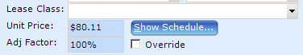

Lease Class
(Tab stop 8) Use Leasing Class to indicate the leasing class of the improvement detail.

To make a change to the Lease Class field, click on the drop down arrow, use the scroll bar to navigate to the correct code, then select the code from the menu.

Unit Price
(Tab stop 9) Unit Price is a non-editable*, display only field that shows the value returned from the cost schedule when a match is made between the Type, Method, Class and Sub-Class fields and a schedule.
!
User Tip: Upon recalculation, if the Unit Price field returns a zero (0), the user should verify the correct entries were made in the Type, Method, Class, Sub-Class, Condition and Feature fields. In Clark County’s version of PACS, a zero (0) means that the schedule could not make a match with the data on the improvement detail.

*User Tip: There are circumstances in which the Unit Price field is editable. In order to be editable, two conditions must be met:
- The user must have the appropriate user rights and
- The Method must be set to SP (Special Property)

Show Schedule
(Tab stop 10) The Show Schedule button is provided as a user shortcut, eliminating the need to go into the administrative code file module to view schedules. The user can select the Show Schedule button to open a view of the improvement schedule being used to generate the unit cost for the detail. Those with appropriate user rights can make edits directly in the schedule dialog.

PLEASE DO NOT ATTEMPT TO EDIT SCHEDULES!
(We are still working out the bugs for user rights and you can do serious damage to the values by playing around in this functionality).

Adj Factor
(Tab stop 11) The Adj Factor field (aka as Adjustment Factor) is used to directly adjust the Unit Price on an improvement detail. Allowable entries in this field range from 0% to 300%.

To make a change to the Adj Factor field:
- Click into or tab to the Override checkbox to open the Adj Factor field to edits.
- Click into the Adj Factor field
- Input the requested percent as a whole number between 0 and 300. PACS will automatically add the % sign.

Override
(Tab stop 12) See notes for Adj Factor Field

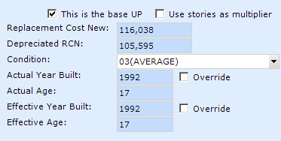

This is the Base UP
(Tab stop 13) The checkbox is an indicator used in the schedule building process. In PACS it is possible, but not required, to value an improvement detail with a Unit Price that is based on a percentage of another detail’s Unit Price. To do so, PACS needs to know which detail to use as the base unit price in the percentage calculation. When the checkbox is active (checked), PACS knows to use the unit price from this detail to apply the percentage amount against.

User Tip: only one improvement detail on a parcel should have the checkbox set active. If more than one detail has this active, then PACS will generate a Recalculation Error (that’s bad).
!
Residential User Tip In Residential improvement schedules, this checkbox should be checked for the MA(Main Floor) Improvement Detail. The other floors, (MA2, MA3, MA4, etc., rely upon costs from the main floor detail).

User Tip:
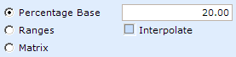
Image taken from a schedule where the detail’s
unit price will be 20% of the indicated detail’s unit price.

This user tip is directed only to users who have user rights to build improvement schedules. The following information is from the TA online user guide:
Percentage Base - If you want to price the schedule from a percentage of the main area, enter a percentage in this field. For example, an open porch price per square foot is 20% of the main area's price per square foot.
Note: The unit cost and value of this segment will be zero if none of the main area improvements are designated as ‘This is the base UP’.

Historical Note: The 2008 migration logic used for this field was such that the checkbox was set active for improvement details equal to ‘MA’(MAIN FLOOR) or ‘MH’(MOBILE HOME). Where an improvement had multiple MA details, the MA detail with the largest value was set as the base unit price.

Use stories as multiplier
(Tab Stop 14) To use this functionality, click in the checkbox. See user tip below for details.

User Tip: the user should be aware that the Stories field acts as an Area (sq.ft.) field multiplier when the checkbox is active (checked). For commercial properties, this checkbox should be checked. For example, if the subject property is a two story office building with 5,000 sq.ft. of floor area on each floor, the user can input a ‘2’ in the Stories field, activate the checkbox, and input 5,000 sq.ft. into the Area (sq.ft.) field. PACS will multiply the 5,000 sq.ft by ‘2’ to calculate an Adjusted Area = 10,000 sq.ft.

Replacement Cost New
(Tab stop 15) The Replacement Cost New field is non-editable, display only.
The calculation model for this field will be added to this document at a later date.

Depreciated RCN
(Tab stop 16) The Depreciated RCN (replacement cost new) field is non-editable, display only.
The calculation model for this field will be added to this document at a later date.

Condition
(Tab stop 17) The Condition field is used to describe the observed condition of the Improvement Detail.

To make a change to the Condition field, click on the drop down arrow, use the scroll bar to navigate to the correct code, then select the code from the menu.
!
User Tip: Be aware that changing the condition on one improvement detail does not automatically change the condition on all the other details. You must determine which details the condition change should apply to, and then manually make the change to each detail.

For Residential property, use the following key to make the appropriate entry in the Condition field

Approved CONDITION codes for Residential data entry:
If the observed Condition of the improvement detail is: | Use Condition code: | Notes
Badly Worn | 01
Fair | 02
Average | 03
Good | 04
Very good | 05
Excellent | 06
Worn out | 01WO | Note: this code is for use with Outbuildings only.
Badly worn | 02BW | Note: this code is for use with Outbuildings only.
Average | 03AV | Note: this code is for use with Outbuildings only.
Good | 04GD | Note: this code is for use with Outbuildings only.

Residential Internal note: much cleanup needs to occur on condition codes to make them uniform. Then schedules need to be checked to make sure they are all pointing to the 01-06 codes in the matrices.

Residential User Tip: Starting with the 2010/2011 Cycle 2 revaluation and new construction pid’s, a condition code is required for Detached Garage and Carport details. These details now have the same depreciation schedule as Single Family Residences.
!

For Commercial property, use the following key to make the appropriate entry in the Condition field
Approved CONDITION codes for Commercial data entry:
If the observed Condition of the improvement detail is: | Use Condition code: | Notes
Some improvement detail Types like TANKS do not require an entry in the Condition field | Leave Blank
WORN OUT | 01WO
BADLY WORN | 02BW
Fair | 02
AVERAGE | 03AV
GOOD | 04GD
VERY GOOD | 05VG
EXCELLENT | 06EX

Commercial User Tip: When entering residential improvement data, you must follow the residential data entry guidelines.

The link below is for David and Tami only. Please do not use it!
This table should show all occurrences of Condition codes in NH 0-9999
..\..\1.Conversion Topics\Issues - Commercial\OLTP - Improvement Details Condition Count.rpt

Actual Year Built
(Tab stop 18) To add to or edit the Actual Year Built field, the user must first click inside the Override checkbox which will activate the field. Click inside the field. Input the correct Actual Year Built data.

User Tip: note that PACS is designed so that the information input into the Actual Year Built field at the Improvement level is automatically “pushed down” to the Actual Year Built field on ALL of the Improvement’s Details, unless the field at the Improvement Detail Level has the override checkbox set active (checked). Once the Override checkbox is set active, the pushdown functionality is inoperable.

Override
(Tab stop 19) See instructions for Actual Year Built

User Tip: This tip is for users who are keyboard oriented and use the Tab key to navigate from field to field in PACS. Once you tab to a checkbox, press the Space Bar on the keyboard to activate (check) or deactivate (uncheck) a checkbox field.

Actual Age
(Tab stop 20) Actual Age is a calculated, non-editable field.

Effective Year Built
(Tab stop 21) To add to or edit the Effective Year Built field, the user must first click inside the Override checkbox which will activate the field. Click inside the field. Input the correct Effective Year Built data.

User Tip: note that PACS is designed so that the information input into the Effective Year Built field at the Improvement level is automatically “pushed down” to the Effective Year Built field on ALL of the Improvement’s Details, unless the field at the Improvement Detail Level has the override checkbox set active (checked). Once the Override checkbox is set active, the pushdown functionality is inoperable.
!
User Tip: The Effective Year Built field drives the Effective Age field, which is used in the depreciation model to calculate depreciation.
!
User Tip: For Residential Improvements, updates to Effective Year Built should be made at the Improvement level, rather than at the detail level.

Override
(Tab stop 22) See instructions for Effective Year Built

Effective Age
(Tab stop 23) Effective Age is a calculated, non-editable field.

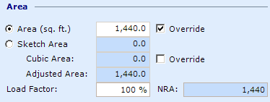

Area (sq.ft.)
(Tab stop 24) To add to or edit the Area (sq.ft.) field, the user should click in the Area (sq.ft) radio button first, if not already active. Next, click inside the field then input the correct square feet data for the improvement detail.
User Tip: The Area (sq.ft.) field is a calculated field if the is unchecked.
If unchecked, PACS multiplies the field data by the field data to calculate the Area (sq.ft.). In 2008, for the migration from CATS to PACS, the CATS area sq.ft. was migrated into the PACS Area (sq.ft.) field with the set active (checked). In this instance, it is possible that no data exists in the Length and Width fields. (Reference tfs Bug #11151)
!
Commercial User Tip: If the Area (sq.ft) field is null or zero (0), the cost section will produce a zero value.

Override
(Tab stop 25) See instructions for Area (sq.ft.).

Sketch Area
(Tab stop 26) To use the Sketch Area field data in the value calculation, the Sketch Area radio button must be set active (checked).

User Tip: The Sketch Area field is non-editable from the Improvement Detail Panel. To edit the Sketch Area data, the user must activate the sketch tool, select this detail, and change the perimeter of the detail to calculate a different area. The data displayed in the Sketch Area field is automatically pulled from the sketch.

User Tip: The sketch tool is activated by selecting the Sketches button on the Improvement dialog.

Cubic Area
(Tab stop 27) The Cubic Area field is a calculated field. To add to or edit the Cubic Area data, the user must first click inside the Override checkbox which will activate the field. Next, click inside the field then input the correct Cubic Area data for the improvement detail.

User Tip: The Cubic Area field is a calculated field. PACS multiplies the data in the Length, Width, and Height fields to calculate the Cubic Area. Use the override functionality if necessary to change the data.

User Tip: All three fields, Length, Width and Height must be filled out to activate the Cubic Area calculation routine. If only the Length and Width fields are filled out, the Cubic Area will remain zero (0).

Override
(Tab stop 28) See instructions for Cubic Area.

Adjusted Area
(Tab stop 29) Adjusted Area is a calculated, non-editable field.

Load Factor
(Tab stop 30) To add to or edit the Load Factor field, tab to or click inside the data entry box and input the correct load factor.

NRA (Net Rentable Area)
(Tab stop 31) NRA is a calculated, non-editable field.

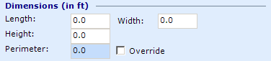

Length
(Tab Stop 32) To add to or edit the Length field, tab to or click inside the data entry box and input the correct length.

Width
(Tab stop 33) To add to or edit the Width field, tab to or click inside the data entry box and input the correct width.
!
Residential User Tip: Length and Width are required fields for Mobile Home Improvements.

Height
(Tab stop 34) To add to or edit the Height field, tab to or click inside the data entry box and input the correct height.
!
Commercial User Tip: Height is a required field for commercial cost tables. The schedule is designed with ranges of heights (0 to 7, 8 to 10, etc…). If the user enters a height value in the height field that falls in between a beginning or ending point on the range, PACS will default to the next highest ending point in the range. For example, if the user enters 25’ and there is no value for 25 feet but a value range for 24’ to 26’, PACS will use the value multiplier for 26’. Floor heights in the schedule start at 7 or 8 feet depending on the building type and run in full foot increments until they switch to two foot increments for taller roof heights. Since all schedule ranges start with zero (0), the user is warned that zero is a valid entry but will produce a zero value for the detail.

Perimeter
(Tab stop 35) The Perimeter field is a calculated field. To add to or edit the Perimeter data, the user must first click inside the Override checkbox which will activate the field. Next, click inside the field then input the correct perimeter data for the improvement detail.

User Tip: The Perimeter field is a calculated field. PACS multiplies the data in the Length field x 2 and the Width field x 2 and sums the resultants to calculate the Perimeter. Use the override functionality if necessary to change the data.
!
Residential User Tip: Pool perimeter is stored here, and is used in schedule lookups.
!
Commercial User Tip: Perimeter is a required field for commercial cost tables. Perimeter should be entered as the Average Perimeter. If the perimeter field is null or zero (0), the cost section will produce a zero value.

Override
(Tab stop 36) See instructions for Perimeter.

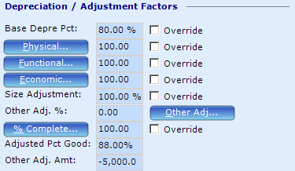

Rather than repeat the same instructions over and over again, the reader should by now be familiar with the operational characteristics of the Override functionality. If not, please refer to the override instructions found on Pages 1 to 23 (XX to XX).

Likewise, four of the blue “Buttons” are note fields the user should select to open and leave specific notes about the adjustment made. (The Other Adj… button is not a note field and will be discussed in detail below)

Base Depr Pct
(Tab stop 37) The Base Depreciation Percent field is populated by a depreciation schedule and can be overridden per the override functionality.

Physical, Functional, and Economic
(Tab stops 40, 43 and 46) To add or edit these fields, the user must first click inside the Override checkbox which will activate the field. Next, click inside the field, then input the percent data.
!
User Tip: In PACS, depreciation is handled as percent good or percent of the detail remaining as opposed to measuring or reporting the amount of the improvement detail that has depreciated or wasted away. For example, if a detail has physically depreciated 9%, it should be reported in PACS as 91% good. If Functional Depreciation is measured at 32%, then it should be reported in PACS as 68% good.

User Tip: (Commercial - Base Depreciation is considered normal physical depreciation.) (Residential – Base Depreciation is derived from the sales / depreciation study and measures all forms of depreciation) Use the Physical Depreciation field to measure additional physical depreciation over and above the base physical depreciation. Click on the blue Physical… button to leave a detailed note explaining why the additional physical depreciation was needed and how it was calculated. Of course, always leave the date, your initials and appraiser number in the note in case others have questions for you later.

User Tip: For Commercial properties, the Override checkboxes for Base Depr Pct, Physical, Functional, and Economic depreciation fields should be active (checked). Override checkboxes set active at the Improvement Detail level makes the pushdown functionality inoperable. For more information on depreciation and PACS pushdown functionality, please see the instructions in Section XX (Improvement Panel)

Size Adjustment
(Tab stop 48) To add or edit the Size Adjustment field, the user must first click inside the Override checkbox which will activate the field. Next, click inside the field then input the percent data.

User Tip: Clark County will not use this field until policies explaining the appropriate use for this functionality can be written and added to this manual.
!
Commercial User Tip: When processing a DOR Exemption where a portion of a building is exempt, the Size Adjustment field can be used to successfully allocate the correct % of building value to both the taxable portion and exempt portion of the improvement. It is important on both the taxable PID and exempt PID to maintain the total building size in the Area (SqFt) field or Adjusted Area field so that the correct Unit Price is applied when valuing on the cost approach to value.
Also! You must remember to link the properties together.
- Go to the Split Merge & Property Links panel
- Select the green Add button (if this is the first time)
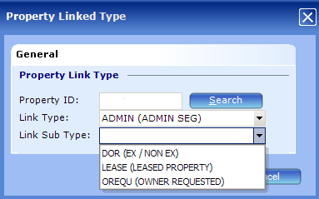
- Type in the correct PID in the Property ID field
- Select ADMIN (ADMIN SEG) in the Link Type field
- Select the appropriate choice in the Link Sub Type field
- Click “OK” to complete the linking process

Other Adjustments
Occasionally it is necessary for an appraiser to make specific value adjustments to an improvement detail. Functionality programmed into the Other Adj… button allows the user to make these adjustments.



Other Adj. % (Field)
(Tab stop 50) The Other Adj. %: field display is not editable. The field reports the percentage adjustments the user makes via the Other Adj… button.
(Reviewer note: See bug HS91369)

Other Adj. Amt (Field)
The Other Adj. Amt: field display is not editable. The field reports the combined fixed dollar adjustments the user makes via the Other Adj… button.

The data for the Other Adj. Amt: field will come from summing imprv_det_adj.imprv_det_adj_amt where imprv_det_adj.imprv_det_adj_method = ‘A’ for all imprv_det_adj records associated with the current imprv_detail record.

Other Adjustment (Button)
(Tab stop 51) Apply Improvement Detail specific adjustments as follows:

- Open the PID where the adjustment is to be applied
- Select the Improvement Panel
- Identify and select the correct Improvement
- Select the Detail button to open the Improvement
- In the Details Grid, identify and select the Improvement Detail to which the adjustment will be applied
- Select the Detail button to open the Improvement Detail
- Select the Other Adj… button to open the Improvement Detail Adjustments dialog:
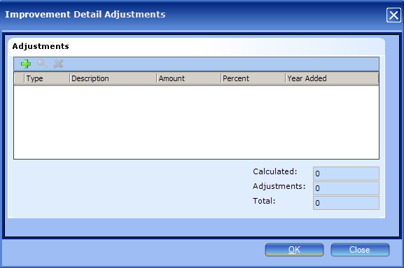

The Improvement Detail Adjustment dialog has three command functions:
The Add Button – use from this location to add a new adjustment
The Details Button – use from this location to view or edit an existing adjustment
The Delete Button – use from this location to delete an existing adjustment

- Select the Add button to open the Adjustment Detail dialog: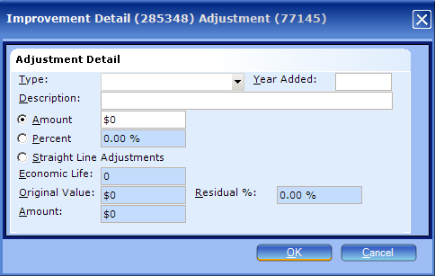
- Click the dropdown arrow in the Type field
- Select the appropriate adjustment Type
- Click in the Year Added field and add the current year
- Input the appropriate description for this adjustment type in the Description field
- Select either the Amount radio button or the Percent radio button and input the required data

User Tip: Do not use the Straight Line Adjustments radio button until these instructions are updated to explain the functionality.
!
User Tip: PACS should not allow you to enter a negative percentage, but currently it does and will display the -5.00% entry in the Other Adjustment field like this: , assuming this was the only adjustment made. However, the calculation model ignores the adjustment thus misleading the casual user into thinking the adjustment is being made. Therefore, do not enter a negative percentage like -5.00%. Rather, you must enter this figure as 95% in order for the calculation to work correctly. A positive 10% adjustment must be entered like this: 110.00%

User Tip: The calculation routine used in the Adjustment Detail dialog is linear first, then additive. This means that percentage adjustments calculate against the DRCN amount independent of other adjustments whether the other adjustments are percents or flat dollar amounts. Once all the adjustments have been calculated they are summed up to arrive at the total adjustment. Also, the inquisitive may want to know that the difference between the RCN and the DRCN is in the calculated adjustment total but is not displayed or identified anywhere else.

User Tip: Adjustments made via the Other Adjustment functionality do not affect Flat Values.

- Select the OK button to complete the adjustment entry.

% Complete
(Tab stop 53) To edit the % Complete field, the user must first click inside the Override checkbox which will activate the field. Next, click inside the field then input the percent data.
!
User Tip: For Residential property, do not use this % Complete field (unless you want to track a % complete for a single detail, and not the entire improvement). Rather, use the % Complete field at the Improvement Level.

Adjusted Pct Good
(Tab stop 55) Adjusted Pct Good is a calculated, non-editable field.
The calculation model for this field will be added to this document at a later date.

Improvement Detail Features

Improvement Detail Features are used to identify various components of an improvement detail that may or may not add value. The user should be very careful to select the correct Feature Type and Feature as these items may be linked to a schedule and therefore would be necessary in order to calculate a correct unit price on the detail.
!
User Tip: For purposes of Reval data entry, Feature Types should already be applied to the parcel (as a result of migration logic). Therefore, it is expected that the user should only need to update the existing Feature (2nd Column). In the event you need to add a new Feature Type to the parcel, you will need to check with David or Tami to verify the correct entry to make. Incorrect entries may cause schedule errors. David and Tami are working on an Appendix to be added to this document to provide instructions for making new entries.

User Tip: For purposes of New Construction data entry, the user will need to use the Reference Account functionality as explained in Section XX of ___________document.

User Tip: Administrators should know that Feature Type codes are called Attribute Codes in PACS.Admin - Improvement’s code file menu.

Administrative User Tip: Feature Types can be added by county staff but in order to make them available to a schedule matrix, you must contact True Automation and request the new Feature Type be made available to the matrix functionality.

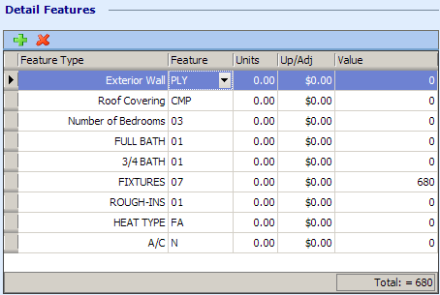
The Improvement Detail Features Grid consists of five columns:
- Feature Type
- Feature
- Units
- Up/Adj
- Value

The Add Button – use from this grid to add a new Feature Type record, then follow the edit instructions shown below to complete the data entry process.
The Delete Button – use from this grid to delete an existing Feature Type record
The Edit Button does not exist for this grid. Follow the instruction below for the Feature Type field to make edits.

Feature Type
(Tab stop 56) To edit the Feature Type field:
- Click into the Feature Type field on the item you want to change.
User Tip: Note, if you used the green add button to add a Feature Type for the first time, PACS will automatically populate the Feature Type field with the first item in the list (Construction Style) and display a warning symbol in the Feature field to indicate these are required fields. So make sure you correct the auto populated entry (Construction Style) to the one you want.
- The list of all Feature Types is displayed
- Use the scroll bar to navigate up or down to browse through the available choices
- Select the new Feature Type from the list
- Click into the Features field (2nd column) adjacent the Feature Type you are on
- Select the appropriate item from the Features list
- Select the Apply button
- Repeat steps 4 through 7 until edits are complete
- Select the Recalculate button and check for recalculation errors by viewing the recalc status on the blue banner header.
- Select the OK button to close the Improvement panel

Feature
(Tab stop 57) As mentioned in the user tip on Page XX, for purposes of Reval data entry, Feature Types should already be applied to the parcel (as a result of migration logic). Therefore, it is expected that the user should only need to update the existing Feature (2nd Column).

To edit the Feature field:

- Select the Feature Type you want to edit by clicking on the one you want to edit.
- Next, click into the Feature field to activate the drop down menu arrow.
- The list of Features is displayed, if not, click on the drop down arrow
- Use the scroll bar to navigate up or down to browse through the available choices
- Select the new Feature from the list
- Select the Apply button
- Repeat steps 1 through 6 until edits are complete
- Select the Recalculate button and check for recalculation errors by viewing the recalc status on the blue banner header.
- Select the OK button to close the Improvement panel

Note: Some ‘Feature Types’ are mandatory in order for the cost schedules to work correctly. The tables below only show only the required Feature Types for Residential parcels and Commercial parcels. For a complete listing of all Feature Types and their intended use, please see Appendix XXX for Residential instructions and Appendix YYY for Commercial instructions.

Required Feature Types codes for Residential data entry (by Improvement Type):
Feature id | Feature Type | Used in Schedule to derive value | Notes:
Improvement Types: (R)Residential and (M)Mobile Homes
3 | Exterior Wall | Yes – modifies base unit price | Exterior Wall is required on the ‘MA’ (Main Floor) Improvement Detail Type, It is also required for these Improvement Detail Types: ‘BUILTINGAR’, ‘ATTGAR’,
6 | Roof Covering | Yes – modifies base unit price | Roof Covering is used to modify the base cost on the ‘MA’ (Main Floor) or ‘MH’ (Mobile Home) Improvement Detail Type.
28 | HEAT TYPE | Yes – modifies base unit price | Heat type is used to modify the base cost on the ‘MA’ or ‘MH’ Improvement Detail Type.
125 | LIFE EXPECT | Yes – used for depreciation on Mobile Homes | LIFE EXPECT is required on ‘MH’ (Mobile Home) Improvement Detail Types for MH Improvements only
10 | FIREPLACE | Yes | Use on the ‘MA’ or ‘MH’ improvement detail type
26 | FIXTURES | Yes | Use on the ‘MA’ or ‘MH’ improvement detail type
27 | ROUGH-INS | Yes | Use on the ‘MA’ or ‘MH’ improvement detail type
29 | A/C | Yes | Use on the ‘MA’ or ‘MH’ improvement detail type
33 | BG SPACES | Yes – although BG spaces migrated, it is not required for schedules | BG Spaces is not required
34 | AG COMMON WALL | Yes - NO | AG Common wall is no longer used in a Attached Garage schedule
Improvement Type: POOL (Pool)
37 | POOL HEATER | Yes
38 | POOL DB | Yes
39 | POOL CHLOR | Yes
198 | POOL TYPE | Yes
Improvement Type: (DGAR ) Detached Garage
3 | Exterior Wall | Yes

User Tip: For purposes of Residential Reval data entry, the user should verify that each account has the correct Feature Type codes listed above.
!

Approved Feature Types codes for Commercial data entry:
Feature Type | Used in Schedule to derive value | Notes/Exceptions:
Heating/Cooling | Yes
ELEVATOR | Yes
COST SECTION | Yes - Required | Not required on Detail Types = ASP, OTHER, WDROOF, FENCE, LOADWELL etc... (Hint: These are CATS Lump Sum items)
LIFE EXPECT | Yes
SPKLR-WET | Yes
SPKLR-DRY | Yes
Interior Finish |  | See Appendix YYY
!
User Tip: For purposes of Commercial Reval data entry, the user should verify that each parcel has the Feature Type codes listed above if the improvement actually has the item. For example, an office building has an elevator. If the appraiser does not add the ELEVATOR feature type, the schedule will still return a unit price factor – however, it will be wrong since it will not include the cost of the elevator.

The link below is for David and Tami only. Please do not use it!
Link to Attribute review file:
..\..\1.Conversion Topics\Issues - Code File Cleanup - David & Tami\improvements.attributes (features) - under review.xls

New Value Paragraph*
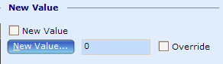

New Value (Checkbox)
(Tab stop – not assigned) Click inside the checkbox to set it to active (checked)

New Value (Button)
(Tab stop – not assigned) Select the button to open a history of new construction value on this detail

New Value (Field)
(Tab stop – not assigned) To add to or edit the New Value field, the user must first click inside the Override checkbox which will activate the field. Next, click inside the field then input the correct dollar amount of new construction for the improvement detail.

Override
(Tab stop – not assigned) Click inside the checkbox to set it to active (checked)

*Instructions for adding New Construction Value are found below:

NEW CONSTRUCTION – Steps TO ADD NC VALUE FOR A NEW IMPROVEMENT DETAIL
- Open the PID where the new construction is to be added
- Open the Improvement panel
- If the situation requires a new improvement, the user should create a new improvement now. If not, open the affected improvement.
- On the improvement panel, in the New Value paragraph, click in the “New Value” checkbox, then click in the “Improv Detail” radio button 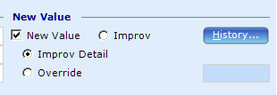
This step tells PACS to get the new construction value from the Improvement Detail
- Complete other necessary data entry on the improvement panel
- Create the new improvement detail
- Complete the necessary data entry on the improvement detail panel
- Select the recalculate button
- Click in the New Value checkbox to set it to active
- Select the recalculate button again. This step should add the new construction value in the New Value field.
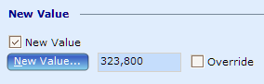
In this example, the new value automatically populates with $323,800.

User Tip: When the New Value checkbox is active, PACS uses the Detail’s Adjusted Value or Flat Value as the new construction value, unless the user overrides the new value and manually adds a different new construction value.
- If step six (10) produced the desired results, complete any remaining data entry and click the “OK” button, which will take you back to the Improvement panel.
- Go to the Values Panel and verify that the correct new construction value is displayed. If it is, then you have completed the NC entry process. If not, check with an Administrator. The Administrator will need to tell you to override the NC value at either the Improvement Level or the Improvement Detail Level. If you are told to override the NC value at the Improvement Detail Level, then you need to override the automated value as follows:
  - Go back to the new improvement detail where you added NC Value.
  - In the New Value paragraph, click in the Override check box
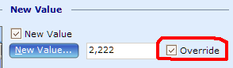
  - Enter the ‘correct’ new construction value in the New Value field
  - Select the Recalculate button
  - Select the OK button
  - Go back to the Value Panel and verify that PACS accepted your override NC value.

Values Paragraph
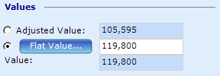

The user must select either the Adjusted Value radio button or the Flat Value radio button depending upon the current office policy (found in a separate document yet to be created.)
!
Residential Note: In the course of Cy 1 Reval data entry do not edit or deactivate the “Flat Value” that was migrated from CATS. While it is our intent that Cy 1 be valued using “Adjusted Value” calculated from schedules for 2009’s assessment, for reval data entry the migrated “Flat Value” should be preserved per management directive.

If office policy directs the user to typically use the Adjusted Value and the user deviates from policy and uses the Flat Value, then the Flat Value note field should be invoked.
- Click in the Flat Value radio button
- Click in the Flat Value field and enter the appropriate Flat Value dollar amount for the improvement
- Select the Flat Value button and the following dialog opens: 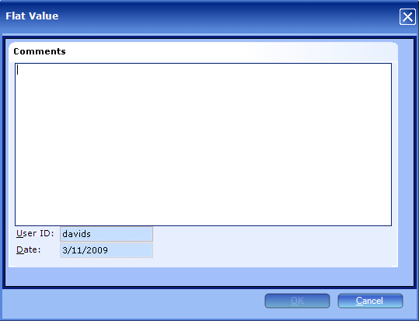
- Enter notes to explain exactly what was done and why the flat value was used. Use the following format:
Date – Appraiser Initials & Appraiser # - Reason (notes)
- Select the OK button to close the Flat Value note field
- Recalculate the parcel
- Select the OK button to return to the Improvement dialog

Section XX: How to Delete an Improvement Detail
See Section XX in the document “Improvements – Improvement panel instructions” (Page 8)

This concludes the Improvement Details panel data entry instructions.

Appendix XXX – MF data entry example – Units Field

The subject property is a to

Appendix XXX – Approved Residential Feature Types: A Complete Listing

Appendix XXX – Complete listing of approved Residential Feature Types:

Feature id | Feature Type | Used in Schedule to derive value | Notes:
Improvement Types: (R)Residential and (M)Mobile Homes Features
3 | Exterior Wall | Yes – modifies unit price | Exterior Wall is required on the ‘MA’ (Main Floor) Improvement Detail Type, e.g., Main Floor. It is also required for these Improvement Detail Types: ‘BUILTINGAR’, ‘ATTGAR’,
6 | Roof Covering | Yes – modifies unit price | Roof Covering is used to modify the base cost on the ‘MA’ or ‘MH’ (Mobile Home) Improvement Detail Type.
28 | HEAT TYPE | Yes – modifies unit price | Heat type is used to modify the base cost on the ‘MA’ or ‘MH’ Improvement Detail Type.
125 | LIFE EXPECT | Yes – used for depreciation on Mobile Homes | LIFE EXPECT is required on ‘MH’ Improvement Detail Types for MH Improvements only
10 | FIREPLACE | Yes | Use on the ‘MA’ or ‘MH’ improvement detail type
26 | FIXTURES | Yes | Use on the ‘MA’ or ‘MH’ improvement detail type
27 | ROUGH-INS | Yes | Use on the ‘MA’ or ‘MH’ improvement detail type
29 | A/C | Yes – modifies unit price | Use on the ‘MA’ or ‘MH’ improvement detail type
33 | BG SPACES | Yes – although BG spaces migrated, it is not required for schedules | No longer required
12 | Sprinkler System |  | Use on MA (Main Floor) or MH Improvement Details
15 | NUMBER OF BEDROOMS
22 | FULL BATH
23 | ¾ BATH
24 | ½ BATH
25 | ¼ BATH
30 | WALL A/C
118 | DECK FLOOR 1
119 | DECK COVER 1
120 | DECK FLOOR 2
121 | DECK COVER 2
199 | PORCH FLOOR 1
200 | PORCH COVER 1
201 | PORCH FLOOR 2
202 | PORCH COVER 2
204 | PATIO COVER TYPE
205 | PATIO SURFACE TYPE
122 | SOLAR HEAT SQFT
52 | ELEVATOR |  | Enter as a Feature type when it is for informational purposes only. If it is valued, enter as an Improvement Detail = ‘EP’(Elevator (Passenger))
31 | SOLAR HEAT
34 | AG COMMON WALL | Yes – No  New: 2010/2011 | No longer required
Improvement Type: POOL (Pool)
37 | POOL HEATER | Yes
38 | POOL DB | Yes
39 | POOL CHLOR | Yes
198 | POOL TYPE | Yes
220 | FREE FORM CUSTOM | Yes | New 2010/2011: Use for free form custom shaped pools. Choose “Y” for Feature
Improvement Type: (08 ) Outbuildings
2 | FOUNDATION
6 | ROOF COVERING
7 | FLOORING
3 | EXTERIOR WALL
Improvement Type: (DGAR ) Detached Garage
3 | Exterior Wall | Yes

Appendix YYY

Commercial Property Instructions for Use of Feature Types

Instructions for the use of “Interior Finish” Feature type.
Feature type of Interior Finish is included in the industrial warehouse building schedule as a feature unit price additive to the replacement cost new. This is intended for use in industrial buildings that have more than the typical office build out in the building, and when the build out is of a higher quality than the building on the main floor.
To add this feature click on the” +” sign and open the drop down menu of feature types: select the Interior Finish feature type. The choice of selections of features are; C-L, C-A, C-G, or C-E. The “C” in front of each code stands for Commercial. The selection is meant to represent the commercial quality of the office space, with L= low, A = average, G = good, and E = excellent. The value for this Feature will display in the “Value” column and automatically add to the Replacement Cost New value calculated as the main floor area by the adjusted Unit Price.
When the Feature Type and Feature are selected the system will default to 1 unit. It is the appraiser’s responsibility to list the corresponding area for the office area. It was deemed that if office space is in excess of the base amount typical for the building type that all of the office should be listed. If there are multiple office spaces of same or different qualities, this Feature Type can be added multiple times. When listing the office build out space it would seem appropriate to make an adjustment in the main floor unit price of the industrial building costs by indexing the unit costs for the loss of value of all office.
If this Feature Type is selected for other type buildings, no value will be calculated or appear at this time.
Mark Rauchenstein (Written: 4/16/09 ) Revised:

Appendix XYZ

Commercial Property Instructions for Use of “C”, “SC”, “S” Type Improvements
When the detail type is: |  | Use the following TYPE code | Use Method | Use Class | Use Sub-Class | Features | Notes
ASPHALT |  | ASP | C | * | * |  | Based on Area
SERVICE STATION BOOTH |  | B | C |  | L,A,G | Value Drivers  CANOPY TYPE:  STL or WD place in the Features field.  LIGHT POLES:  Will need to pick * for the Feature then put # of Poles in the Unit field  YARD IMPROVEMENT:  ASPH or CONC (need to add # of SF of surface area to the Unit field)  Department Practices  EXT WALL  ROOF COVER | Based on Area and Sub-Class  LIFE EXPECT not required for this sch (it is on a fixed 20 yr life)
ALL BASEMENT TYPES  There are two basement TYPES available to the commercial valuations as Improvement Details.  Note: You will use Sub-class to distinguish the type of basement (i.e. Finished, Unfinished) |  | BSMT(C-BASEMENT)  Note: this Basement type is only used in Commercial and the size of this area is not included in the Summary Screen Living area.  FINBSMT(COMMERCIAL FINISHED BASEMENT)  Note: This basement type is only being used in commercial. This type of Basement will included the size in the Summary Screen Living: Area. | Not all methods have associated BSMT schedules | A,B,C,D,S | C-Bsmt Unf (Unfinsished-Commercial),  C-Bsmt Fin(Fisished-Comercial),  C-Bsmt Prk(Basement Parking-Commercial),  C-Bsmt Stg(Basement Storage-Commercial) | Value Drivers  HEATING/COOLING:  Pick one as applicable  COST SECTION:  Pick 1 thru 7 as applicable. Hint: open the schedule and view the title of the 1st Matrix – It will have a number listed in it and this is the cost section number (note: it will not be “OO”).  SPKLR-WET and/or SPKLR-DRY:  User must enter % of bldg covered by sprinklers in the Features field (in increments of 10)  ELEVATOR:  Enter L,A,G, or E in the Features field. (typically you will match elevator feature with sub-class of the improvement detail)  LIFE EXPECT:  Enter as applicable in the Features field.  Department Practices:  TBD | Note to David: Clean up either manual or hopefully programmatically to change all current basement codes to BSMT  Note: don’t forget to add the correct Wall Height and Average Perimeter information
CONCRETE SHIPPING DOCK |  | CONCSHIP |  |  |  |  | No schedule available currently. Mark to review.
CAR WASH – AUTOMATIC  (See Appendix C-CW for advanced data entry instructions) |  | CWA | C | Not needed | L,A,G | Value Drivers  CANOPY TYPE:  STL or WD place in the Features field.  LIGHT POLES:  Will need to pick * for the Feature then put # of Poles in the Unit field  YARD IMPROVEMENT:  ASPH or CONC (need to add # of SF of surface area to the Unit field)  Department Practices  TBD | Based on Area and Sub-Class  LIFE EXPECT not required for this sch (it is on a fixed 30 yr life)
CAR WASH – DRIVE THROUGH |  | CWD | C | Not needed | L,A,G | Value Drivers  CANOPY TYPE:  STL or WD place in the Features field.  LIGHT POLES:  Will need to pick * for the Feature then put # of Poles in the Unit field  YARD IMPROVEMENT:  ASPH or CONC (need to add # of SF of surface area to the Unit field)  Department Practices  TBD | Based on Area and Sub-Class  LIFE EXPECT not required for this sch (it is on a fixed 30 yr life)
CAR WASH – SELF SERVE |  | CWS |  |  |  | Value Drivers  CANOPY TYPE:  STL or WD place in the Features field.  LIGHT POLES:  Will need to pick * for the Feature then put # of Poles in the Unit field  YARD IMPROVEMENT:  ASPH or CONC (need to add # of SF of surface area to the Unit field)  Department Practices  TBD | Based on Area and Sub-Class  LIFE EXPECT not required for this sch (it is on a fixed 30 yr life)
FENCE |  | FENCE | C | Not needed | L,A,G |  | Height is a required field, however it maxs out at 20 feet.
DOCKHIGH LOADING WELL |  | LOADWELL | TBD |  |  |  | Under review by Mark
KITCHENS |  | Being researched – do not use yet
MAIN FLOOR  (APTS, MOST COMMERCIAL, INDUSRIAL PROPERTIES) |  | MA | Method is our old “Occupancy”  Code. Pick from the available list. | A,B,C,D,S | L,A,G,E | Value Drivers  HEATING/COOLING:  Pick one as applicable  COST SECTION:  Pick 1 thru 7 as applicable. Hint: open the schedule and view the title of the 1st Matrix – It will have a number listed in it and this is the cost section number (note: it will not be “OO”).  SPKLR-WET and/or SPKLR-DRY:  User must enter % of bldg covered by sprinklers in the Features field (in increments of 10)  ELEVATOR:  Enter L,A,G, or E in the Features field. (typically you will match elevator feature with sub-class of the improvement detail)  LIFE EXPECT:  Enter as applicable in the Features field.  Department Practices:  TBD | If you find that a unit price = $0 is returned, open the schedule and verify what is being required.
MEZZANINE  Note: You will use Sub-class to distinguish the type of Mezzanine area (i.e. Finished, Unfinished) |  | MEZZ | Pick from the available list. | A,B,C,D,S | C-Offc Mez,  C-Open Mez,  C-Othr Mez,  C-Stor Mez | Value Drivers  HEATING/COOLING:  Pick one as applicable  COST SECTION:  Pick 1 thru 7 as applicable. Hint: open the schedule and view the title of the 1st Matrix – It will have a number listed in it and this is the cost section number (note: it will not be “OO”).  SPKLR-WET and/or SPKLR-DRY:  User must enter % of bldg covered by sprinklers in the Features field (in increments of 10)  ELEVATOR:  Enter L,A,G, or E in the Features field. (typically you will match elevator feature with sub-class of the improvement detail)  LIFE EXPECT:  Enter as applicable in the Features field.  Department Practices:  TBD | Not all schedules contain cost data for mezzanines.  Enter Mezz at type then pick the appropriate method and search the schedule to identify if one exists for the selected “method”.  Wall Height and Average Perimeter are required entries for Mezzanines.
MOBILE HOME PARK |  | MHP | C | * | L,F,A,G,E | Value Drivers  LIFE EXPECT:  Enter as applicable in the Features field.  MHP SPACE SIZE:  Select a unit space size from the Feature field. ( Divide parcel size by number of units for average lot size)  LIGHT POLES:  Will need to pick * for the Feature then put # of Poles in the Unit field  YARD IMPROVEMENT:  ASPH or CONC (need to add # of SF of surface area to the Unit field) | This MHP schedule does not include freestanding buildings on the parcel. Those will need to be added as a separate improvement. Examples: Clubhouse, MHP Office, Swimming Pool, Fencing, Features: RV parking, sports court etc…
STEEL LOADING DOCK |  | STEELOAD |  |  |  |  | Under review by Mark
SERVICE STATION  (Please see Appendix C-SS for advanced instructions and screenshots) |  | SVSTN | C | C,D,S | L,A,G | Value Drivers  CANOPY TYPE:  WD, STL  HI POWER AIR COMPRESSOR:  (Enter Horsepower in the Feature field and the quantity in the Units field)  PIPING FOR PUMPS:  Will need to pick * for the Feature then put # of Dispensers in the Unit field.  LIGHTING POLES:  Will need to pick * for the Feature then put # of Poles in the Unit field.  PIPING FOR TANKS:  Will need to pick * for the Feature then put # of Tanks in the Unit field.  YARD IMPROVEMENTS:  ASPH, CONC  PIPING FOR AIR/WATER:  Will need to pick * for the Feature then put # of Air Filling Stations (Arm & Well) in the unit field.  AIR /WATER ARM:  Will need to pick * for the Feature then put # of Air/Water Arm Unit stations in the Unit field (An Arm unit is the drop down style usually found inside the service bay)  AIR/WATER WELL:  Will need to pick * for the Feature then put # of Air/Water Well Unit stations in the Unit field (An Well unit is typically a free standing device found on the peripheral of the property or next to the fuel dispensers).  FUEL DISPENSER:  Pick the appropriate style of fuel dispenser from the Feature list and type in the correct number of each in the Units field. ***NOTE: Do not use the following Feature Type IDs: #178 thru 189 and 207 thru 212. | Mark will need to change schedule so that the “*” concept works: see PIPING FOR PUMPS matrix, PIPING FOR TANKS matrix, PIPING FOR AIR/WATER matrix,
STORAGE TANKS  Note: Storage Tanks can include water tanks etc and you will still need to use the Feature Type called FUEL CAP, even though the contents of the tank may not be petroleum based.  (Note: please see Appendix C-SS for additional data entry instructions/tanks) |  | TANKS | C | Construction Type of the Tank:  See drop down list | Not needed | Value Drivers  FUEL CAP  Select the tank’s capacity from the Features drop down list | If tanks have different capacities or construction material, you will need to list each tank as a separate improvement detail. If you have identical tanks, then you can list them as one detail and you will need to add the quantity of the tanks in the Area (Sq.Ft.) field. Be sure that the Use Stories as a Multiplier field is “unchecked”.
LOADING DOCK - WOOD |  | WOODLOAD | TBD |  |  |  | Mark to review
SHIPPING DOCK - WOOD |  | WOODSHIP | TBD |  |  |  | Mark to review
WOOD ROOF (BANK CANOPY etc) | From old Lump Sum | WDROOF | C | Not needed | L,A,G
STEEL ROOF (BANK CANOPY etc) | From old Lump Sum | STROOF | C | Not needed | L,A,G

Appendix C-CW
Commercial Property Instructions for entering Car Wash improvements
(Updated 6-28-2011 by Mark R.)

Current Carwash Screen
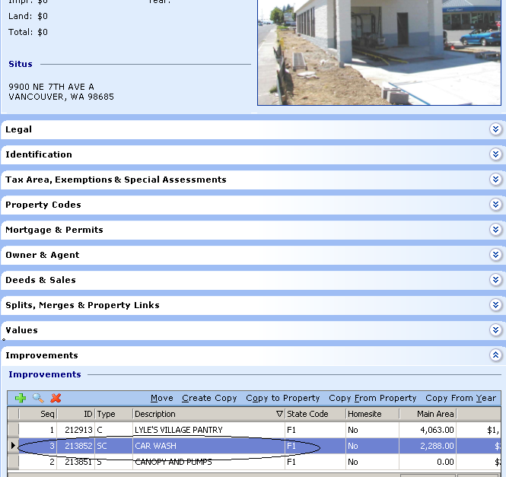
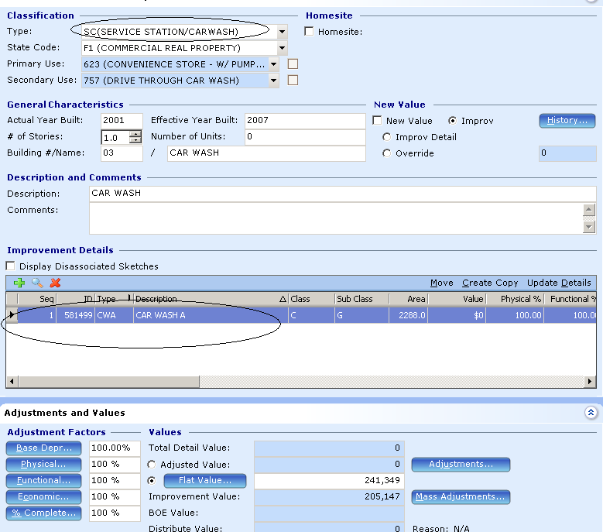

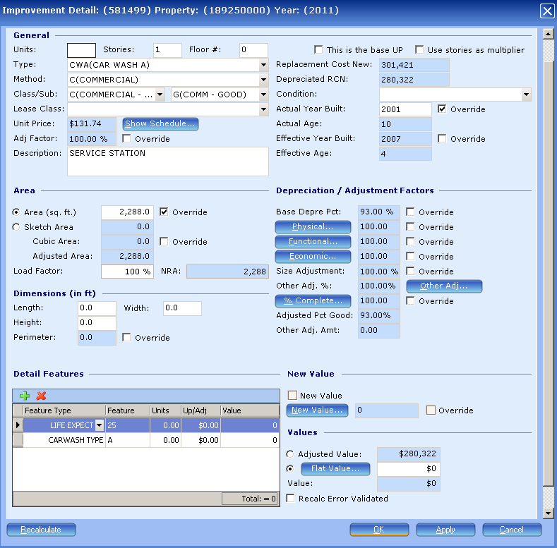

Updating detail data.
Make sure the Type is the CW (Car Wash) type: A = Automatic, D = Drive Through, S = Self Service.
Automatic = Tunnel Full Service, Drive Through = Single car (robot operation), Self Serve = coin op.
The method is always C (Commercial) to find the correct table value.
Class is not required but encouraged for a better description of the construction type.
Subclass is required as the quality of the improvement. Will affect value!
Area is required. Perimeter, Height, Length, and Width are not required.
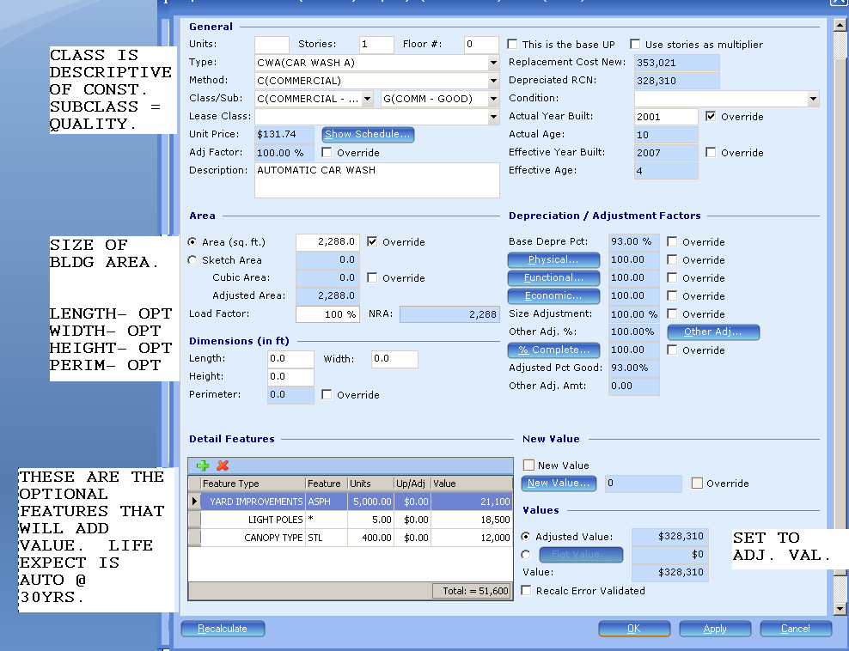The listed Feature Types are the only ones adding or affecting the value. Any other listings are for expanded building description. Basic heating/cooling is included in the building value. The life expectancy is automatic at 30yrs and not modifiable with listing another life expect, only by overriding the Effective Year Built. This depreciation applies to the building and the features. Feature types with a number should be listed as” * “and the number listed in the “Units”. Set value to Adjusted Value or set the Flat value to carry forward. ********* End of Appendix C-CW **********

Appendix C-SS
Commercial Property Instructions for entering Service Station & Tank improvements
(Added 6-28-2011 by Mark R.)
Service Station Data entry.
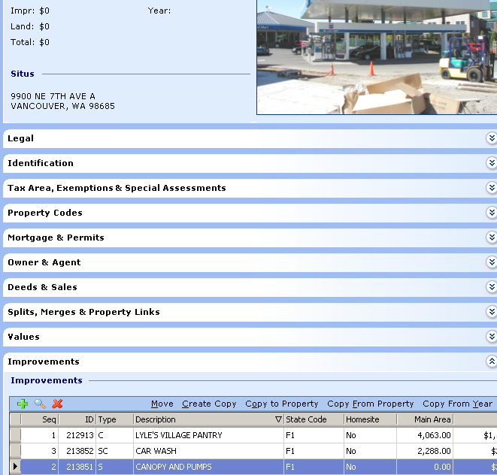
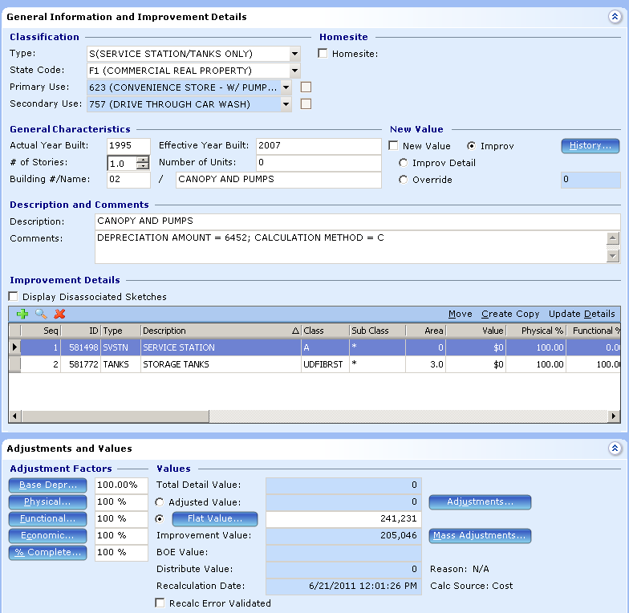
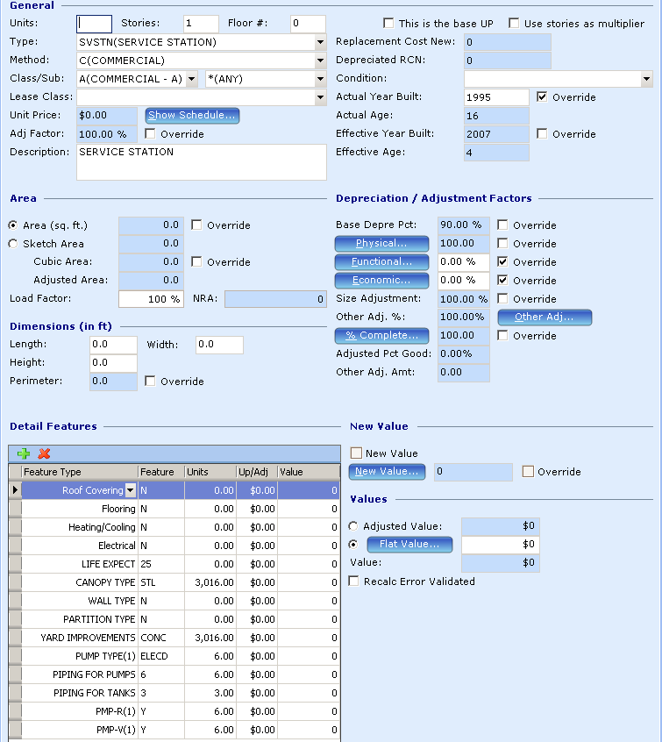
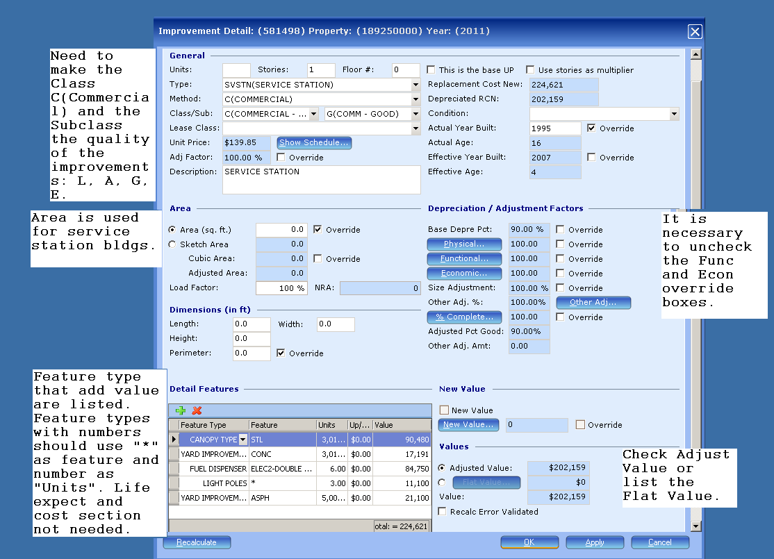
Need to add the improvement quality as the subclass. This will affect the resulting values. By adding the Class of C there will be no error messages. This will display a unit price but will add no value if there is no area.
The area will be used when valuing a service station type building or booth. (Also identify the construction class).
Uncheck the Functional and Economic Adjustment override boxes.
Feature types that are listed add value to service station type properties. Other items that were listed can be removed. No need for life expectancy. The section is automatically set for 25 years. Adjusting depreciation can be done by adjusting the Effective Year Built. Features that are a number should be listed as “*” with the number being used as “Units”.
Check for Adjusted Value or list the Flat Value.

Fuel Storage Tanks. 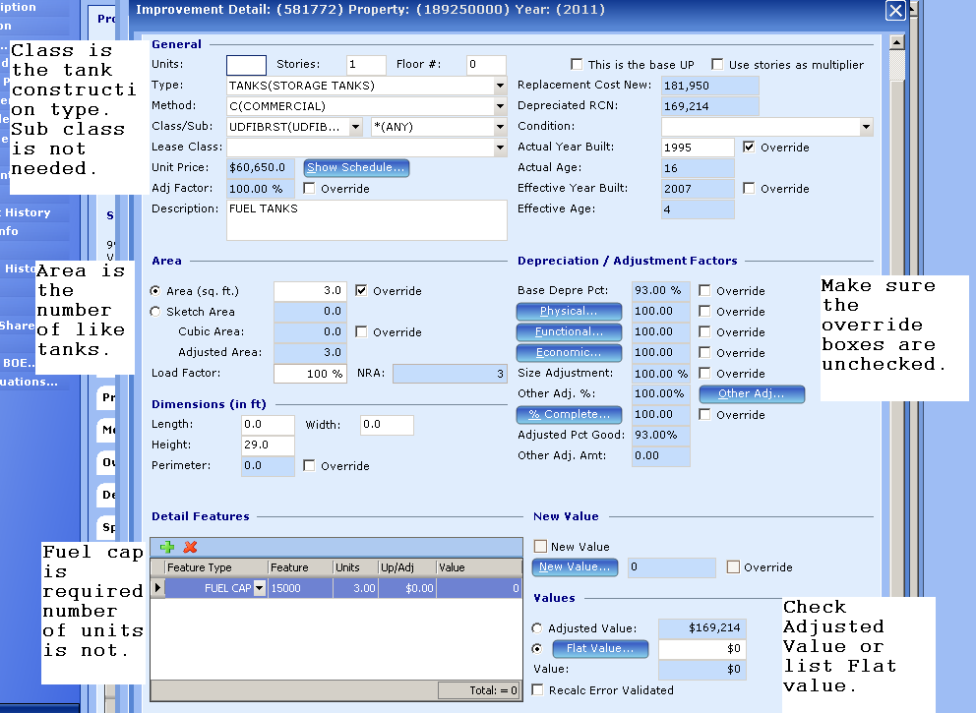
Fuel tanks are listed as Storage tanks. The class is the tank construction. There is no need for a subclass.
The area is the number of tanks being valued. Each screen can only do one type and size of tank. For multiple size tanks there must be a separate screen. The capacity must be listed in the feature to derive a value. There is no need for cost section numbers or life expectancy. Life expect is 30 years for tanks; if an adjustment is needed for depreciation use the Effective Year Built override.
Be sure to check the Econ and Functional Adjustment boxes are unchecked.
Check Adjusted Value or list the Flat Value.

End of Appendix C-SS

xxx

